Extra practice problems for the U13 Nuclear test

1. Determine the energy of a photon that is emitted when an electron on a hydrogen atom falls from the n=5 to to n=3 energy level by using the Rydberg equation.

2. Determine the number of protons, neutrons and electron in .

3. Determine the binding energy of ${}_{78}^{198}{\text{Pt}}$. in J, and in MeV given the mass of the nuclide is 197.96789492 u. Then verify the binding energy per nucleon reported in the table. Would you expect this nuclide to undergo fission or fusion?

4. Use the table of Nuclides to write the nuclear decay reactions for Gold–199, Lead–201, and Polonium–211.

5. Determine the energy released during each of the three reactions you wrote in number 4.

5. Use the table of Nuclides to write the decay series for Uranium – 231 showing the type of decay and the daughter nuclide for each step.

6. You find an old unopened canister that has a label saying it contained 350 g of cobalt -60 when it was delivered on 9/14/81. Determine the amount and identity of nuclides that you expect to be present in 2019. What kind of safety gear would be required for a radiation worker to safely dispose of this canister?

7. Use the following graph to determine the half life of Mg – 28. How long would it take for a 500 g sample to be reduced to less than 1 milligram sample of Mg? What would it turn into?

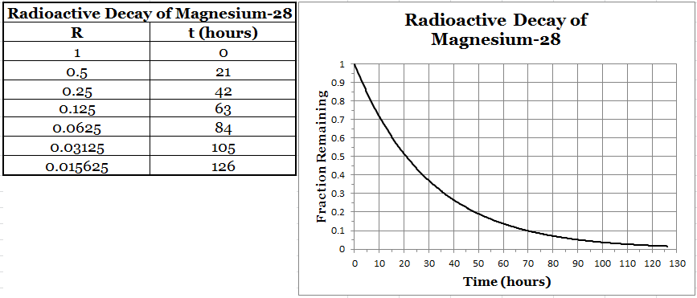

8. When Uranium-235 is bombarded with a neutron, it undergoes fission and forms Krypton-92, a second daughter nuclide and three more neutrons. Determine the identity of the second daughter nuclide and write a balanced nuclear equation for this fission reaction. Use the table of the nuclides and your data packet to determine the energy released in this reaction.

9. Which would you expect to be more dangerous, a sample of Iodine-131 or Radon-222? Why?

